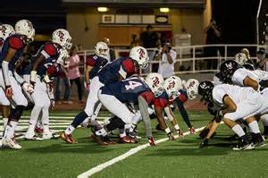

It’s High School Football Time!
Reserve your choice of advertising packages, and we’ll pair each of your ads with features that celebrate the history of high school football, with interesting facts about longstanding rivalries, star players, and more!

Sponsorship Options

Aggressive Plan: ___ ads from ___ to ___, $ ___

Moderate Plan: ___ ads from ___ to ___, $ ___

Conservative Plan: ___ ads from ___ to ___, $ ___

Yes! Count us in!! Please reserve a ________ Plan at $___ for ___ ads.

Advertiser: ______________________ Authorized by: _____________________

Date: ________ Rep: ________

