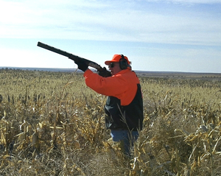

Reserve your choice of Hunting Safety advertising packages . . . we will precede each of your ads with a special :30-second Hunting Safety feature – FREE!

*AGGRESSIVE PLAN* - $

___ ads from ___ to ___

### *MODERATE PLAN* - $

___ ads from ___ to ___

#### *CONSERVATIVE PLAN* - $

___ ads from ___ to ___

**Yes! Count us in!! Please reserve a __________________ Plan at $_____ for ___ ads.**

##### Advertiser: _______________________ Authorized by: _____________________

###### Date: ________ Rep: ________

# ***Hunting Season is Here!***