Salute to Our Police & Firefighters

Just like our military men and women, America’s police and firefighters

put their lives on the line every single day, as they work hard to keep us safe.
(Name of station/group) invites you to join us in a special broadcast tribute
to the men and women of our local police and fire departments.
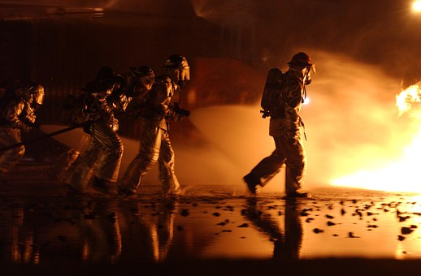

Features will air daily beginning ______, through ______.

SPONSORSHIP OPTIONS:

[ ] 8 times daily - 56 total - $
[ ] 5 times daily - 35 total - $
[ ] 3 times daily - 21 total - $

YES! SIGN ME UP FOR THE PACKAGE INDICATED ABOVE!

FIRM: _______________________________________________________________________

AUTHORIZED BY: ______________________________________________ DATE: _______

