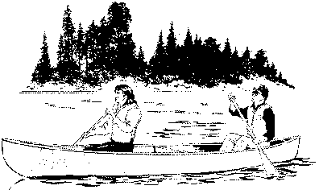****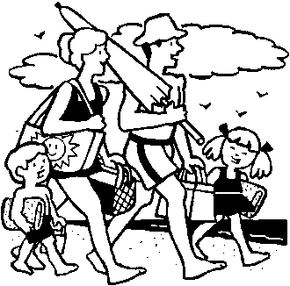



The ***Summer Safety Tips Campaign*** will enhance and reinforce your reputation as a community-minded organization, both to long-time residents and newcomers to the area. They’ll appreciate your leading role in providing them with timely, topical information and sound advice throughout the summer season!

The ***Summer Safety Campaign*** is provided on a *business category exclusive* basis. With your sponsorship at any level, we will not sell the series to any other competing firm. **We will run your features from __________ through __________, for a total of _____ weeks.**

## Sponsorship Opportunities

##### Conservative –

##### Moderate –

##### Aggressive –

**YES! We accept the _______________________ Plan at $______, billed $_____/mo.**

**BUSINESS: __________________________ ADDRESS: _______________________**

**AUTHORIZED BY:__________________________ DATE:_________ REP:_______**