November 11 is Veterans Day.
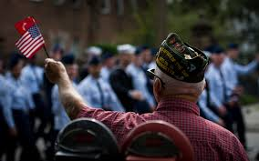

Americans owe a profound debt of gratitude to all of our fellow citizens

who have donned the uniform of our nation’s armed services, whenever and wherever duty called, placing their lives on the line to preserve our liberty.
station calls or logo
invites you to join us in a special broadcast tribute

Features will air daily starting ________ through ________.

SPONSORSHIP OPTIONS:

[ ] 8 times daily - 56 total - $
[ ] 5 times daily - 35 total - $
[ ] 3 times daily - 21 total - $

YES! SIGN ME UP FOR THE PACKAGE INDICATED ABOVE!

FIRM: ______________________________________________________________

AUTHORIZED BY: ____________________________________ DATE: _______

