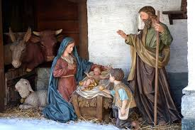
Merry Christmas!

NewsTalk 1150 presents. . . .

Christmas Treasures —
a series of :30-second features that highlight different aspects of Christ’s birth, including Messianic prophecies that were fulfilled at the Nativity and illustrations of Christ’s impact on men and nations throughout history.

Features will air daily beginning _____ through Christmas, December 25.

SPONSORSHIP OPTIONS:

[ ] 8 times daily - 56 total - $750
[ ] 5 times daily - 35 total - $550
[ ] 3 times daily - 21 total - $350

YES! Sign us up for the plan indicated above, at $______ complete.

Advertiser: ___________________________

Authorized by: ____________________________

Date: _____________ Rep: __________________

