For Car Care Professionals Only – a Special Broadcast Marketing Campaign

It’s Fall Car Care Time!

“Talk to Your Car Care Professional....”

Local drivers need to get their cars ready for the change of season!

Choose one of the following packages . . . and we will introduce your ads with one of 10 exclusive Fall Car Care Features FREE!

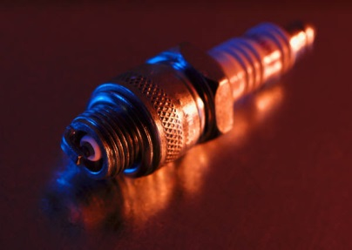
MODERATE - $800
ONE HUNDRED (100) THIRTY-SECOND ADS
50 ON NEWSTALK 1400 AND 50 ON Z-93
PLUS 100 Fall CAR CARE FEATURES FREE!
CONSERVATIVE - $450
FIFTY (50) THIRTY-SECOND ADS
25 ON NEWSTALK 1400 AND 25 ON Z-93
PLUS 50 Fall CAR CARE FEATURES FREE!
AGGRESSIVE - $1125
ONE HUNDRED FIFTY (150) THIRTY-SECOND ADS
75 ON NEWSTALK 1400 AND 75 ON Z-93
PLUS 150 Fall CAR CARE FEATURES FREE!
Yes! Sign us up for the ____________________ plan at $_______!
Advertiser: ________________________ Authorized by: ________________________
Date: _______ Rep: ______

