# *Take Time*

# *to Learn,*

# *So You*

# *Won’t Burn!*

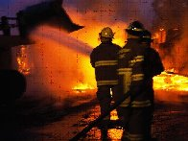

Take advantage of our Fire Prevention special and

remind your customers that you care about safeguarding

their loved ones and their property from the dangers of fire.

Reserve your choice of Fire Prevention advertising packages:

*AGGRESSIVE PLAN* - $

___ ads from ___ to ___

### *MODERATE PLAN* - $

___ ads from ___ to ___

#### *CONSERVATIVE PLAN* - $

___ ads from ___ to ___

Yes! Count us in!! Please reserve a ______________ Plan at $____ for ___ ads.

##### Advertiser: _______________________ Authorized by: _____________________

###### Date: ________ Rep: ________