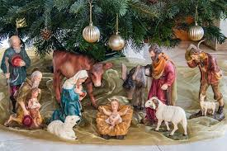
Merry Christmas!

NewsTalk 1150 presents. . . .

Celebrate Christmas! —
a series of :30-second features that present Christmas traditions and history from around the globe, as the world pauses to celebrate the greatest birthday of all!

Features will air daily beginning _____ through Christmas, December 25.

SPONSORSHIP OPTIONS:

[ ] 8 times daily - 56 total - $750
[ ] 5 times daily - 35 total - $550
[ ] 3 times daily - 21 total - $350

YES! Sign us up for the plan indicated above, at $______ complete.

Advertiser: ___________________________

Authorized by: ____________________________

Date: _____________ Rep: __________________

