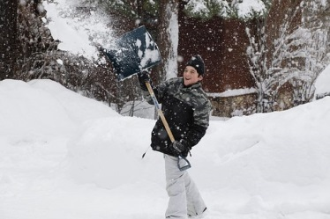
…the habit you live by!
This winter, make
SAFETY…

The Winter Safety Campaign will reinforce your reputation as a community-minded organization, both to long-time residents and newcomers to the area.

The Winter Safety Campaign is provided on a business category exclusive basis. With your sponsorship at any level, we will not sell the series to any other competing firm. We will run your features from ____ through ____, for a total of ____ weeks.

Sponsorship Opportunities

Conservative –

Moderate –

Aggressive –

YES! Sign us up for the plan indicated above, at $_____ complete.

Advertiser: _________________ Authorized by: _________________

Date: _____________ Rep: ____________________

