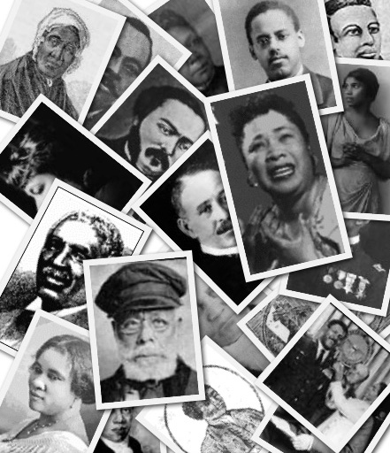

Profiles in Black History

“The world cares very little about what a man or woman knows;
it is what a man or woman is able to do that counts.”
– Booker T. Washington
Reserve your choice of advertising packages, and we’ll pair each of your ads with a Black History vignette – FREE!

AGGRESSIVE PLAN - $
___ ads from ___ to ___

MODERATE PLAN - $
___ ads from ___ to ___

CONSERVATIVE PLAN - $
___ ads from ___ to ___

Yes, count us in! Please reserve a _________ Plan at $_____ for ___ ads.

Advertiser: ___________________ Authorized by: __________________

Date: ________ Rep: ________

