# 

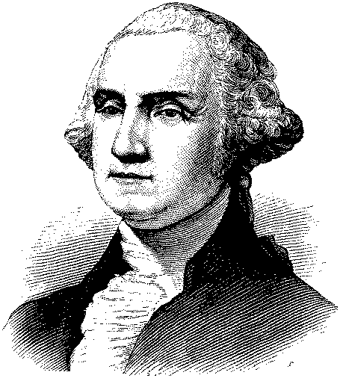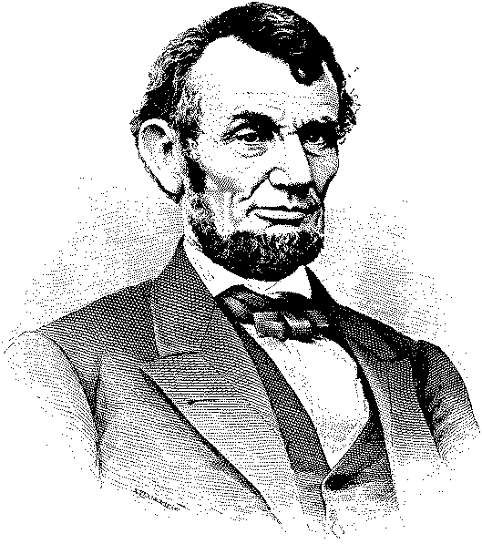

# February ___ is Presidents’ Day!

# Join (station call letters) in celebrating

# two of America’s greatest presidents:

# George Washington and Abraham Lincoln!

**Sponsorship Options**

___ ads from ___ to ___, $ ___

___ ads from ___ to ___, $ ___

___ ads from ___ to ___, $ ___

Yes! Count us in!! Please put us down for ______ads, for a cost of $________.

##### Advertiser: ______________________ Authorized by: _____________________

###### Date: ________ Rep: ________