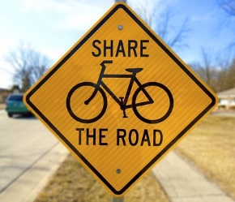

Sponsorship Options

___ ads from ___ to ___, $ ___

___ ads from ___ to ___, $ ___

___ ads from ___ to ___, $ ___

Yes! Count us in!! Please put us down for ______ads, for a cost of $________.

Advertiser: ______________________ Authorized by: _____________________

Date: ________ Rep: ________

Bike Safety Campaign
Help keep our community safe! (Station call letters) invites you to join us in sponsoring a series of :30-second safety tips for bicyclists and the drivers with whom they share the road.

