National Public Safety Telecommunicators Week

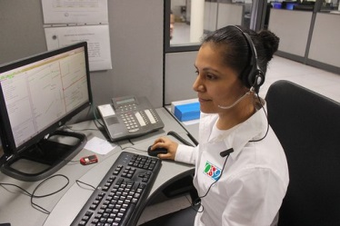
April 14-20, 2019

They’re the unseen heroes: the men and women who take the calls to 911.

(Name of station/group) invites you to join us in a special broadcast tribute
to our local public safety dispatchers:

Salute to Our 911 Operators

Features will air daily beginning ______, through ______.

SPONSORSHIP OPTIONS:

[ ] 8 times daily - 56 total - $
[ ] 5 times daily - 35 total - $
[ ] 3 times daily - 21 total - $

YES! SIGN ME UP FOR THE PACKAGE INDICATED ABOVE!

FIRM: _______________________________________________________________________

AUTHORIZED BY: ______________________________________________ DATE: _______

