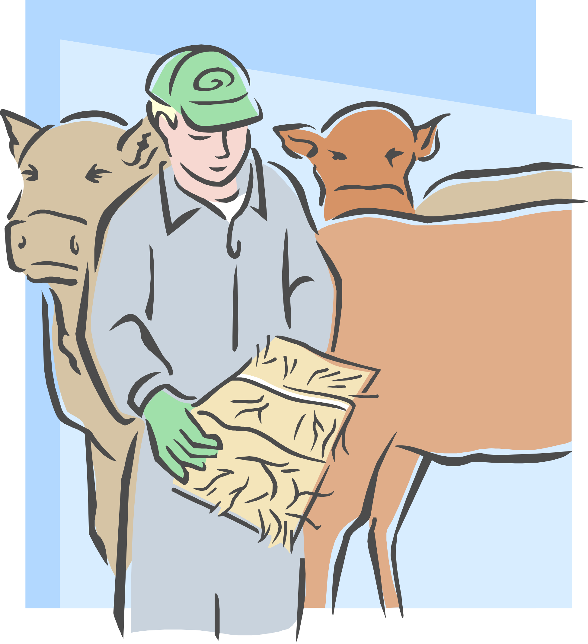
station calls or logo

invites you to take part in
our special broadcast tribute

Salute to the

American

Farmer

Join us in presenting an exclusive tribute
to farm families across the land and right here at home.

AS SPONSOR OF THIS SERIES, YOU RECEIVE A :30-SECOND AD
FOLLOWING EACH OF YOUR SPONSORED AG WEEK FEATURES!
Choose from the following sponsorship packages (rates net to station):

[ ] 70 BROADCASTS (10/DAY,70X TOTAL) - (CATEGORY-EXCLUSIVE) $1050 TOTAL

[ ] 49 BROADCASTS (7/DAY, 49X TOTAL) - (CATEGORY-EXCLUSIVE) $800 TOTAL

[ ] 35 BROADCASTS (5/DAY, 35X TOTAL) - (NON-EXCLUSIVE) $575 TOTAL

YES! SIGN ME UP FOR THE PACKAGE INDICATED ABOVE!

FIRM: _______________________________________________________________________

AUTHORIZED BY: ______________________________________________ DATE: _______

